# Random Variables:

Random variable is a function which maps the real word outcome of a probability space to real numbers.

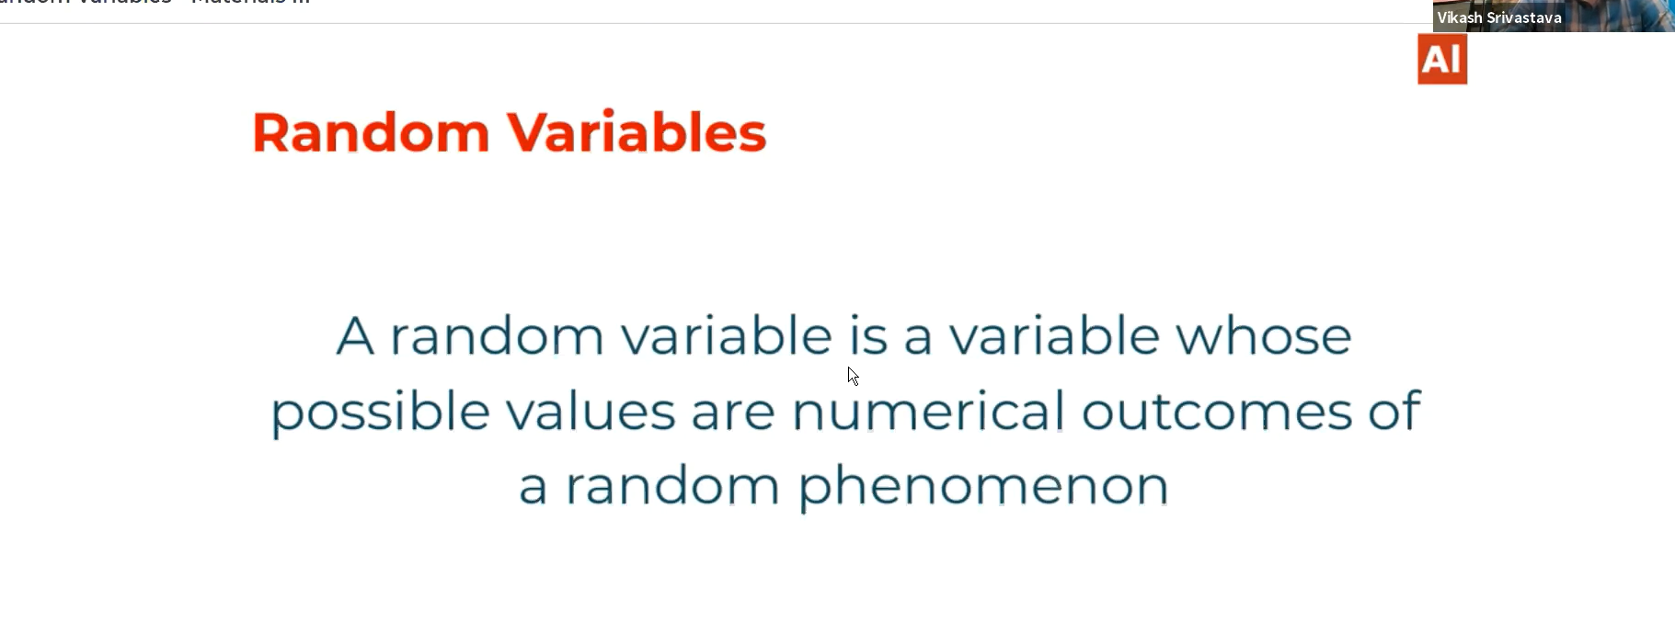

# Take an example:

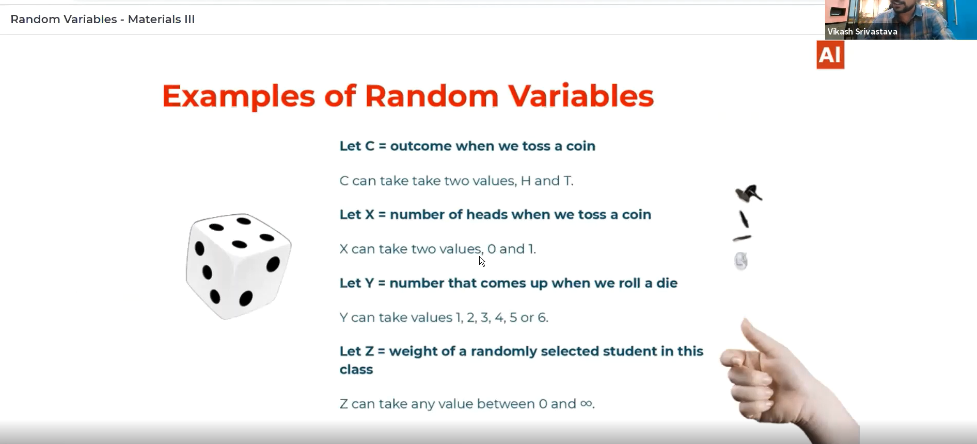

# Domain and Range:

**Domain🡪 The possible values which the function can take.**

**Range🡪 The range of the function.**

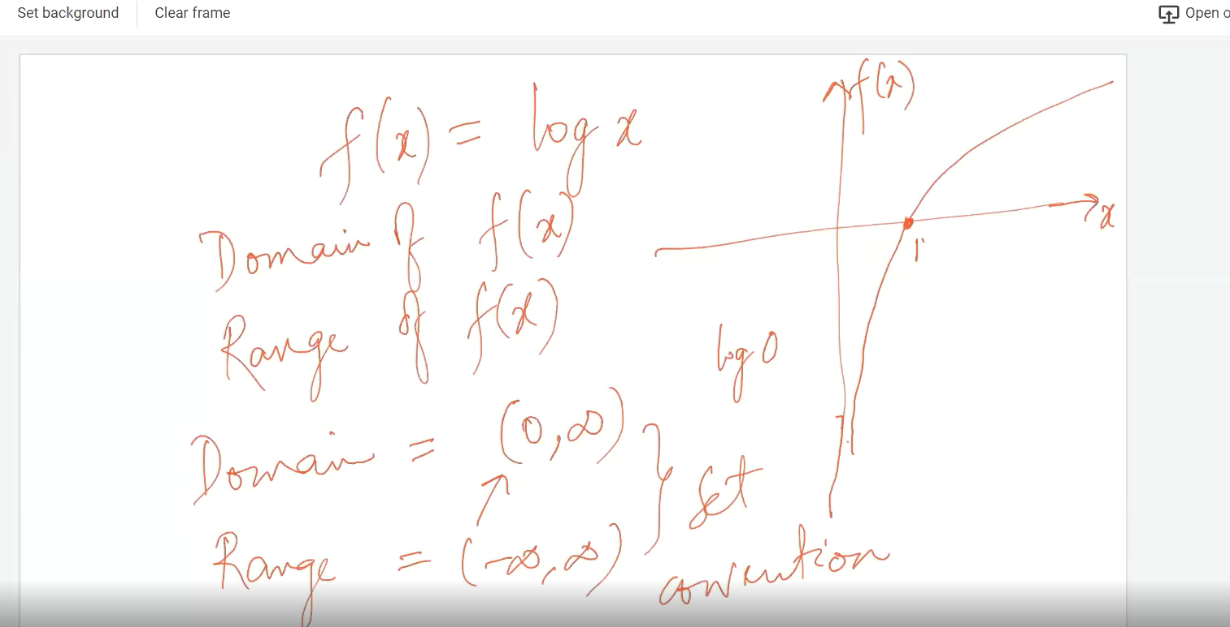

# Ex:2

**X🡪 Function which converts the possible outcome of a sample space to numerical format.**

**w🡪 The possible outcome of a sample space.**

**x🡪 The converted/mapped numbers of X function.**

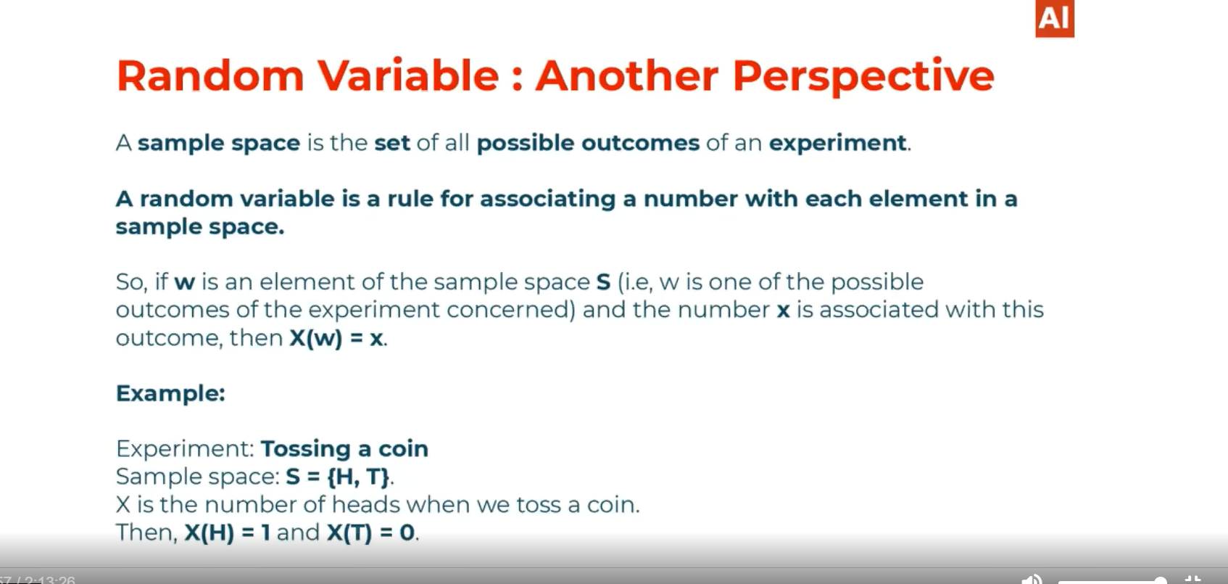

# Ex:3

**X-> Random variable/function which maps the possible outcome of a sample space to a numerical value.**

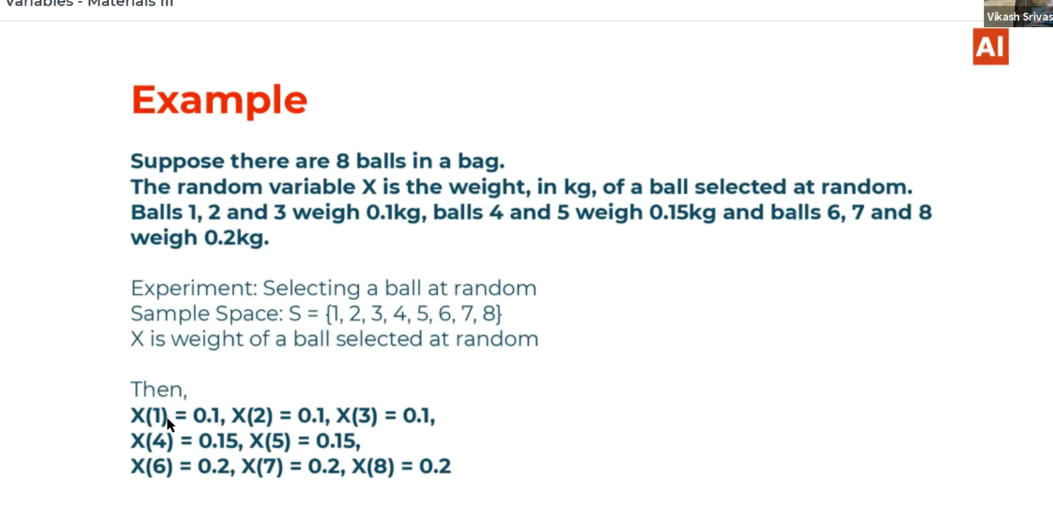

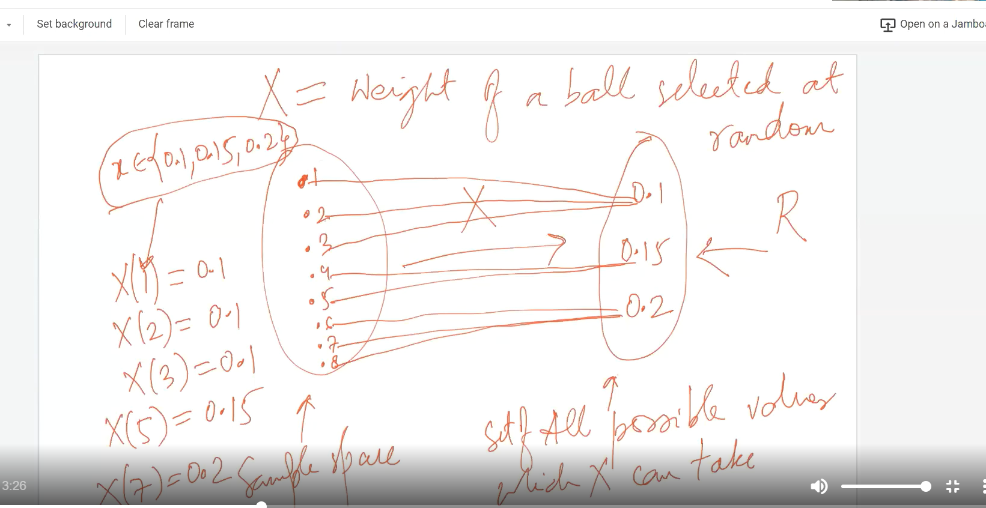

# Types of Random variable:

## 🡪Discrete Random Variable

## 🡪Continuous Random variable

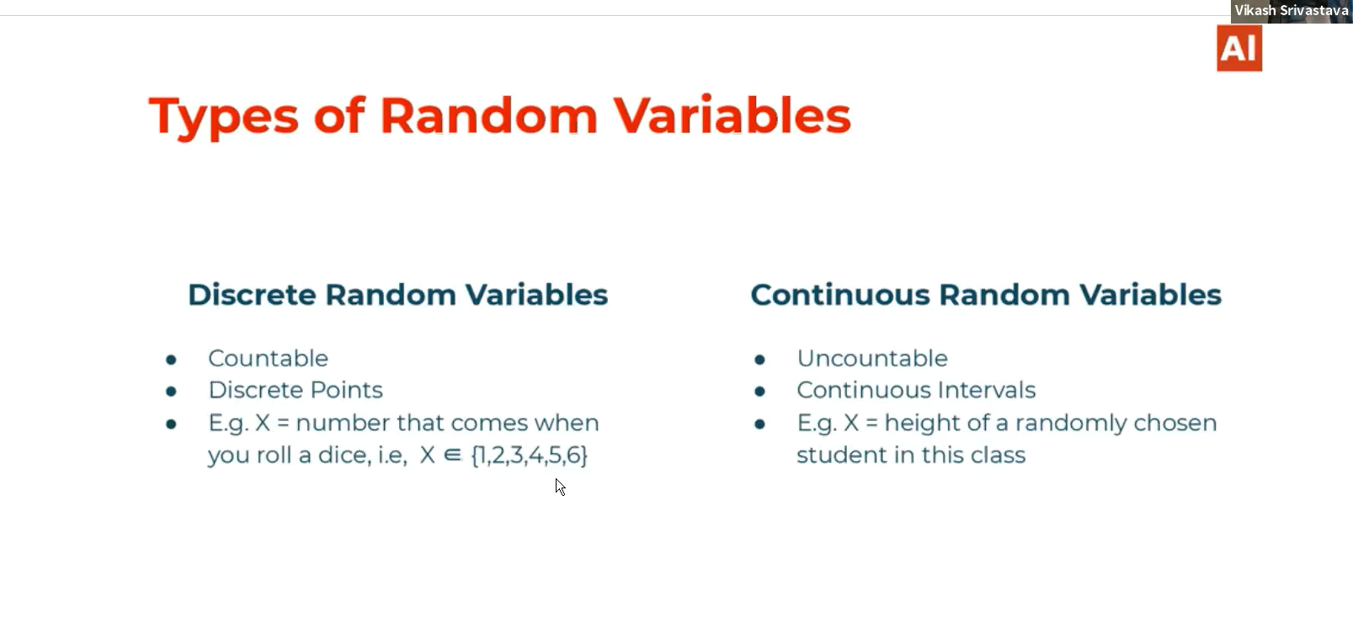

## Countable finite, Countable infinite and Uncountable:

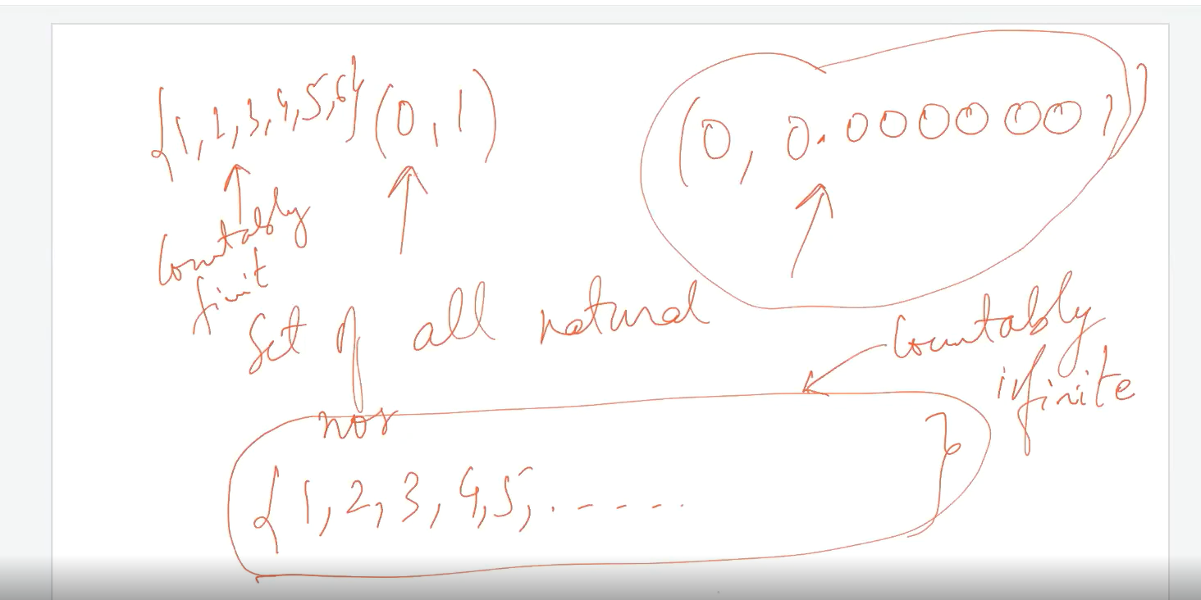

# Probability on Random variables:

Now we understood the concept of random variables now we apply probability on random variables. Probability deals with events of the sample space. If we want to calculate the probability of any event then P(E)=n(E)/n(s).

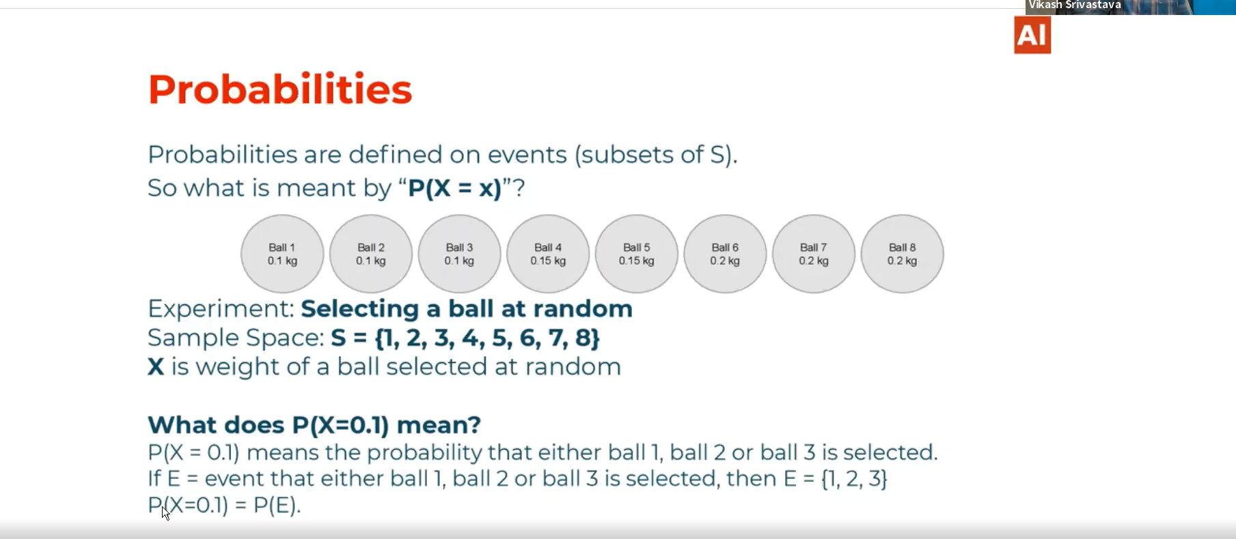

Example of Probability on a random variable, the real meaning of x,X,E,:

The probability of selecting ball weighing 100 gram:

P(X=0.1)==P(E)=n(E)/n(S) == 3/8

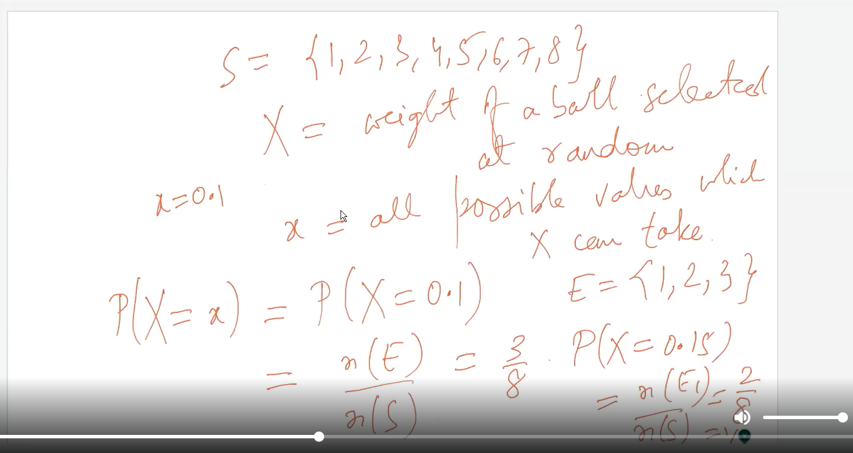

# Probability Distribute Function/ Probability Distribution:(Discrete PDF)

It specifies how the total probability of 1 is divided among the possible probability value of X. PDF and CDF are used for EDA purpose.

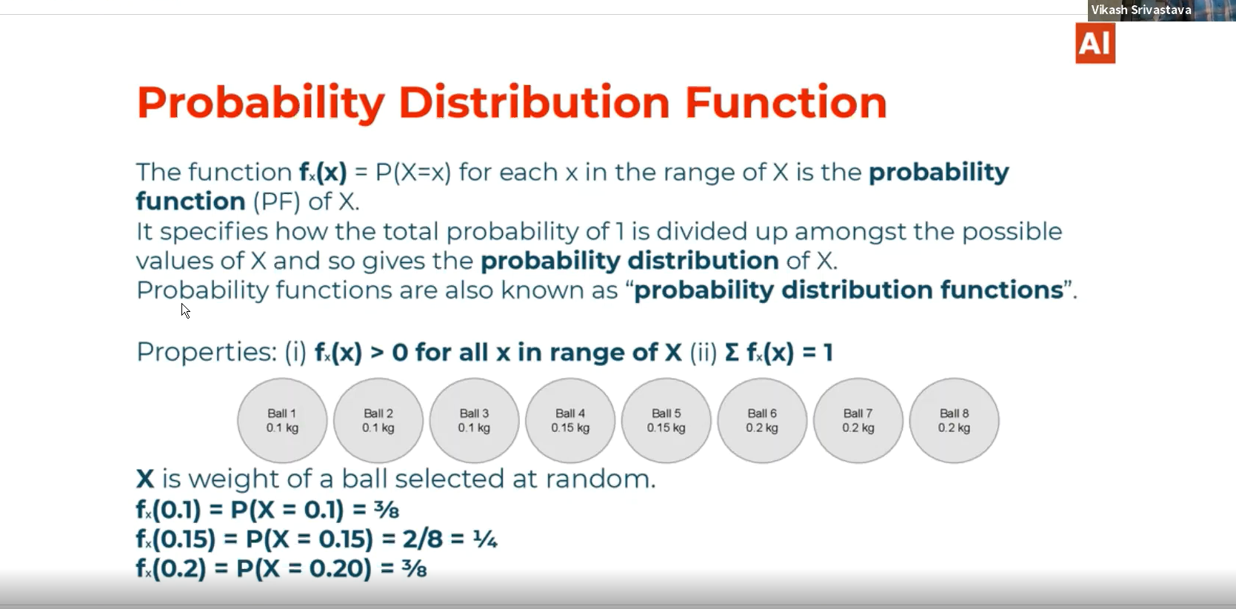

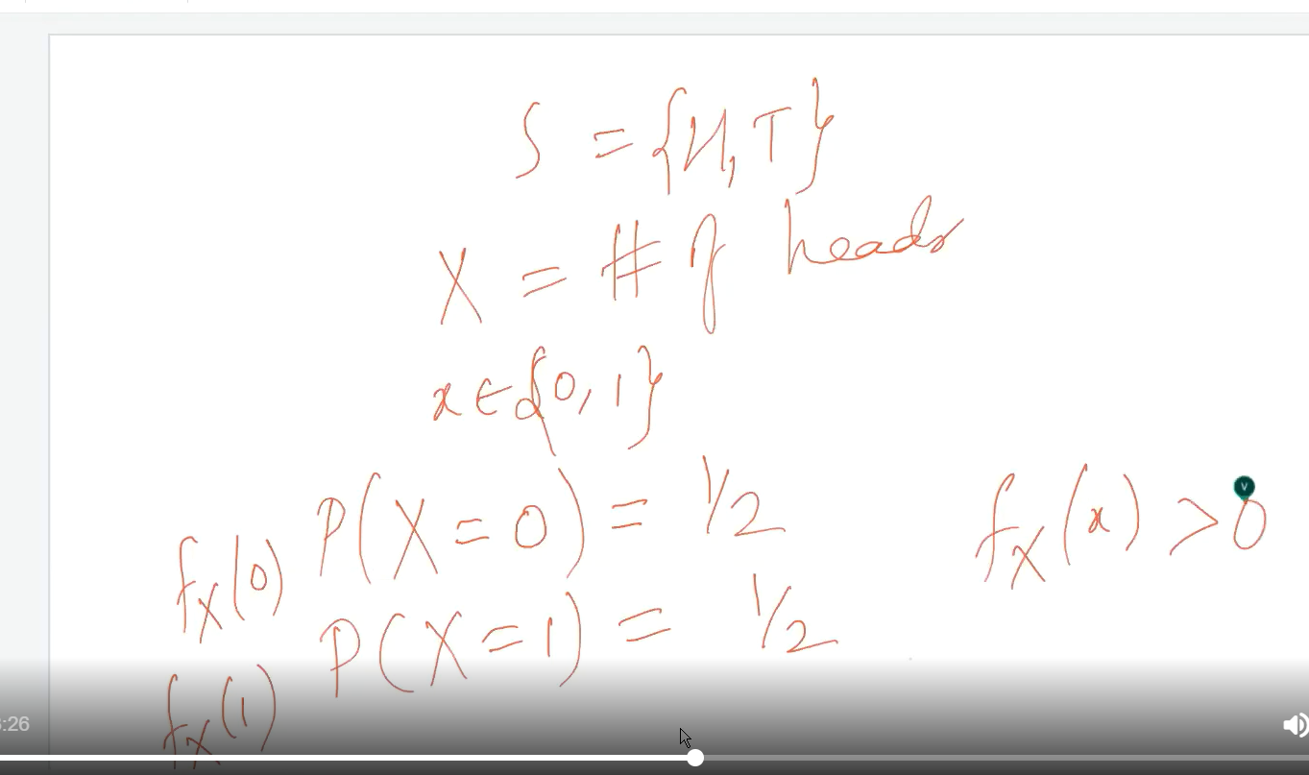

# Cumulative Distribution Function/ Distribution Function:

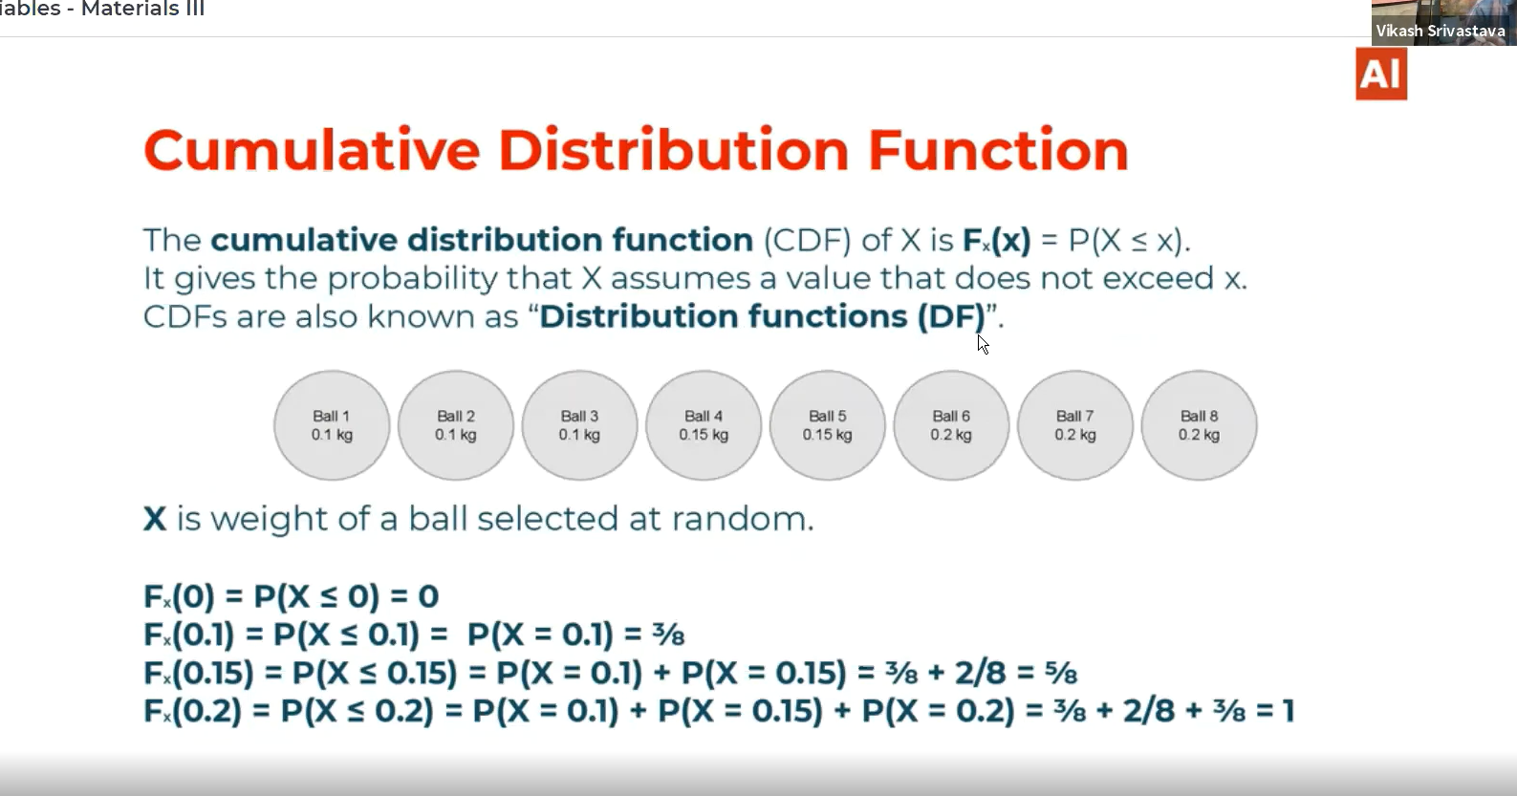

# Discrete CPF ex:

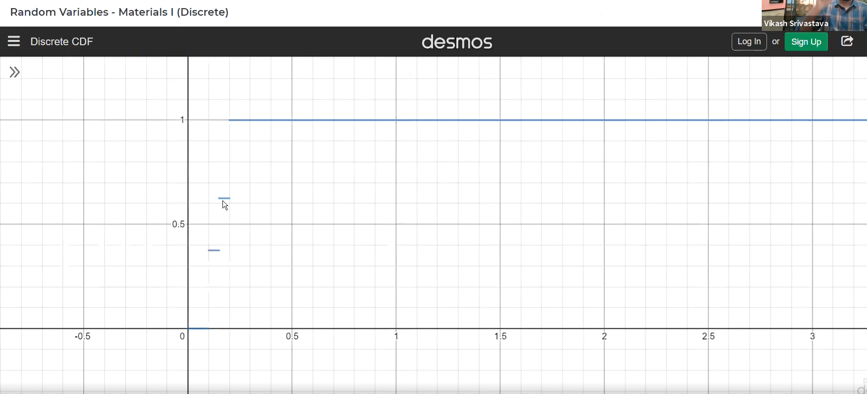

# PDF for Continuous function:

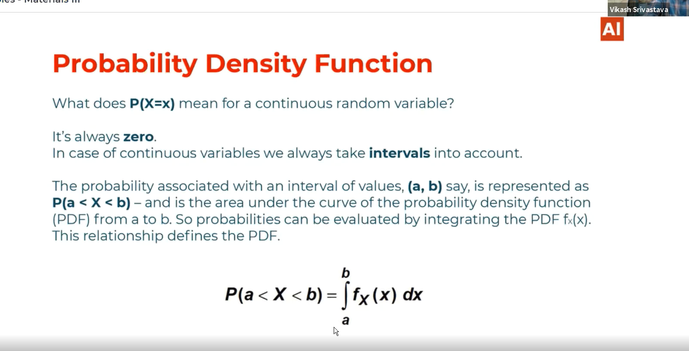

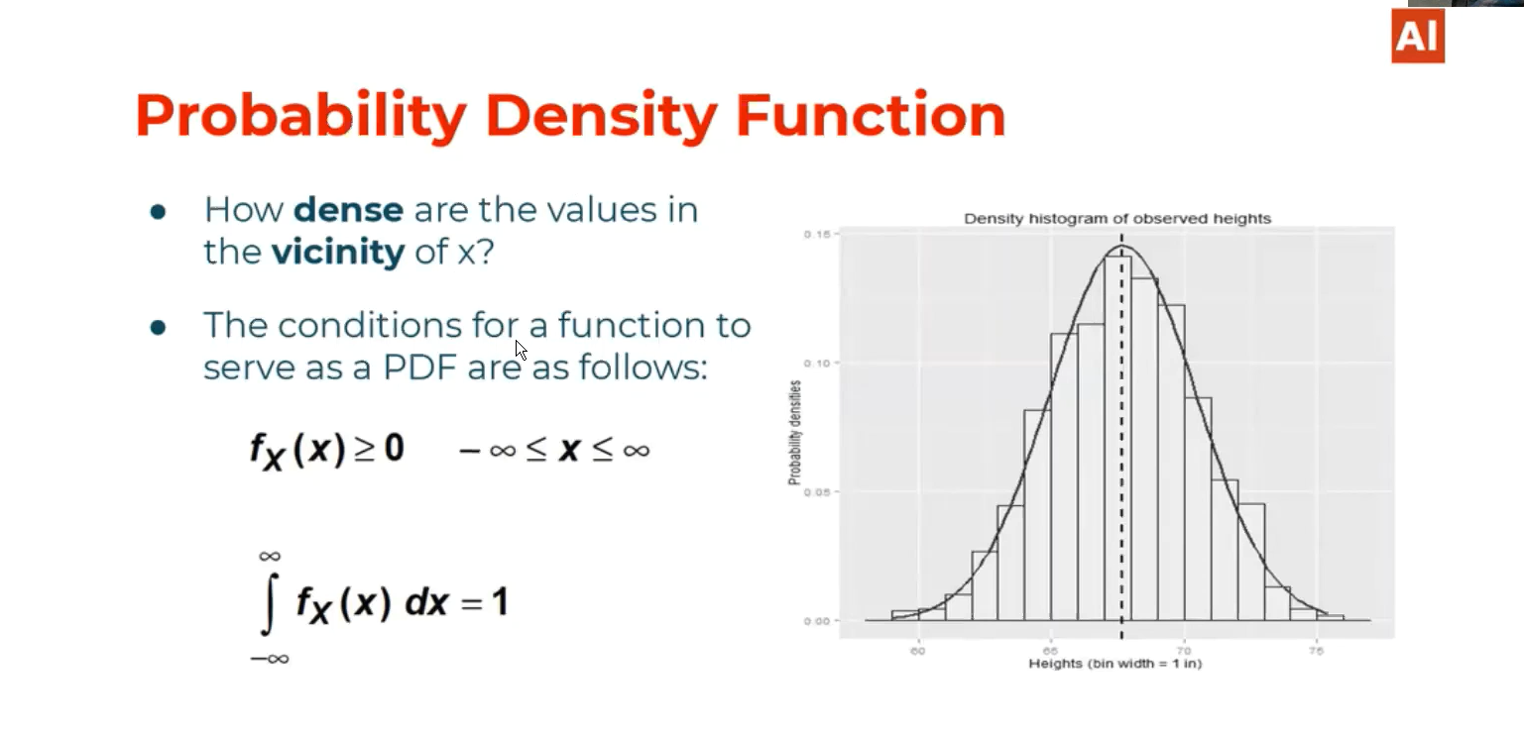

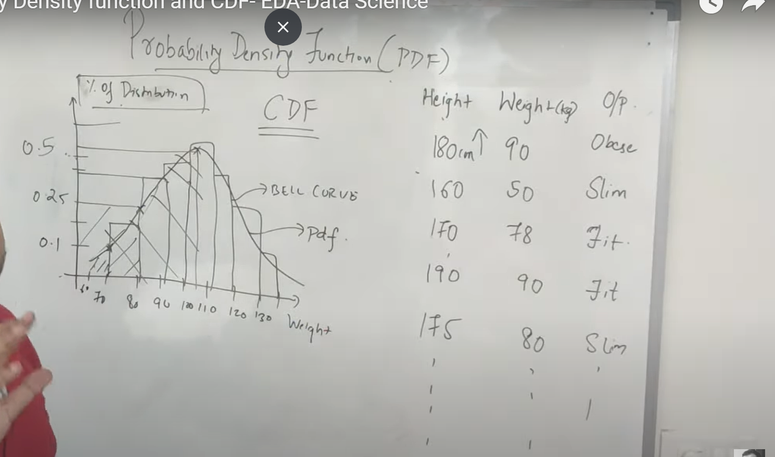

# Checkable things:

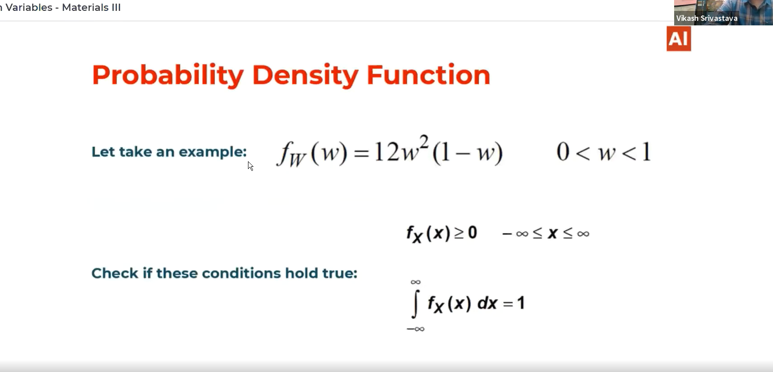

**Ans:**

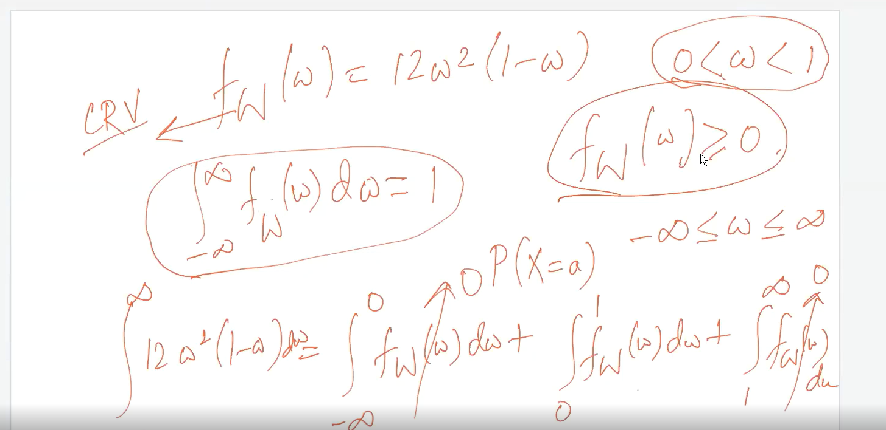

# CDF for continuous random variable:

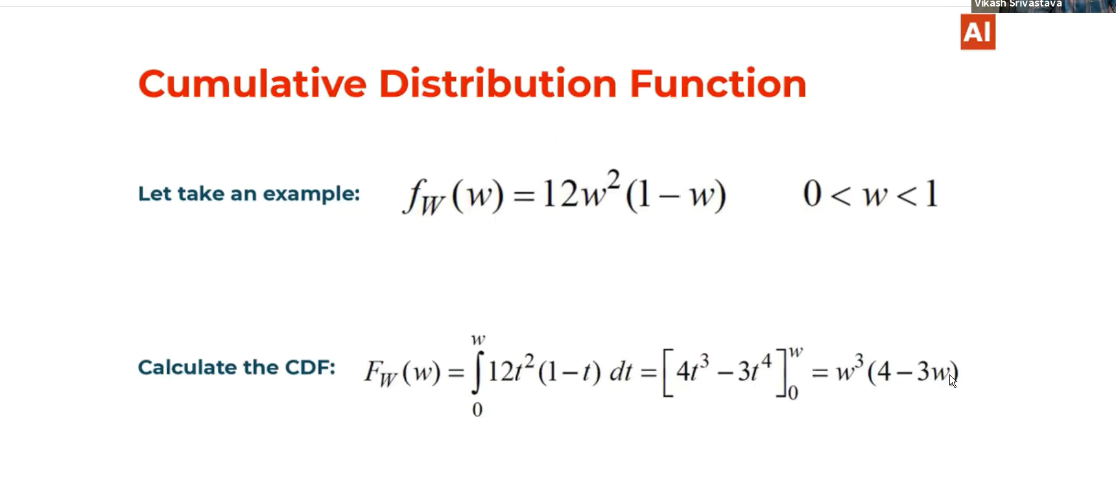

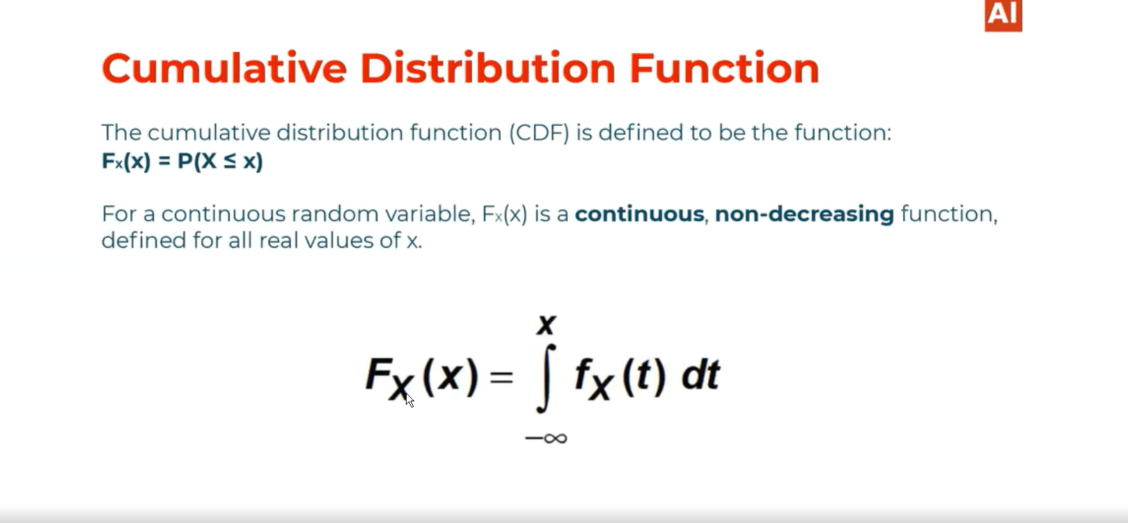

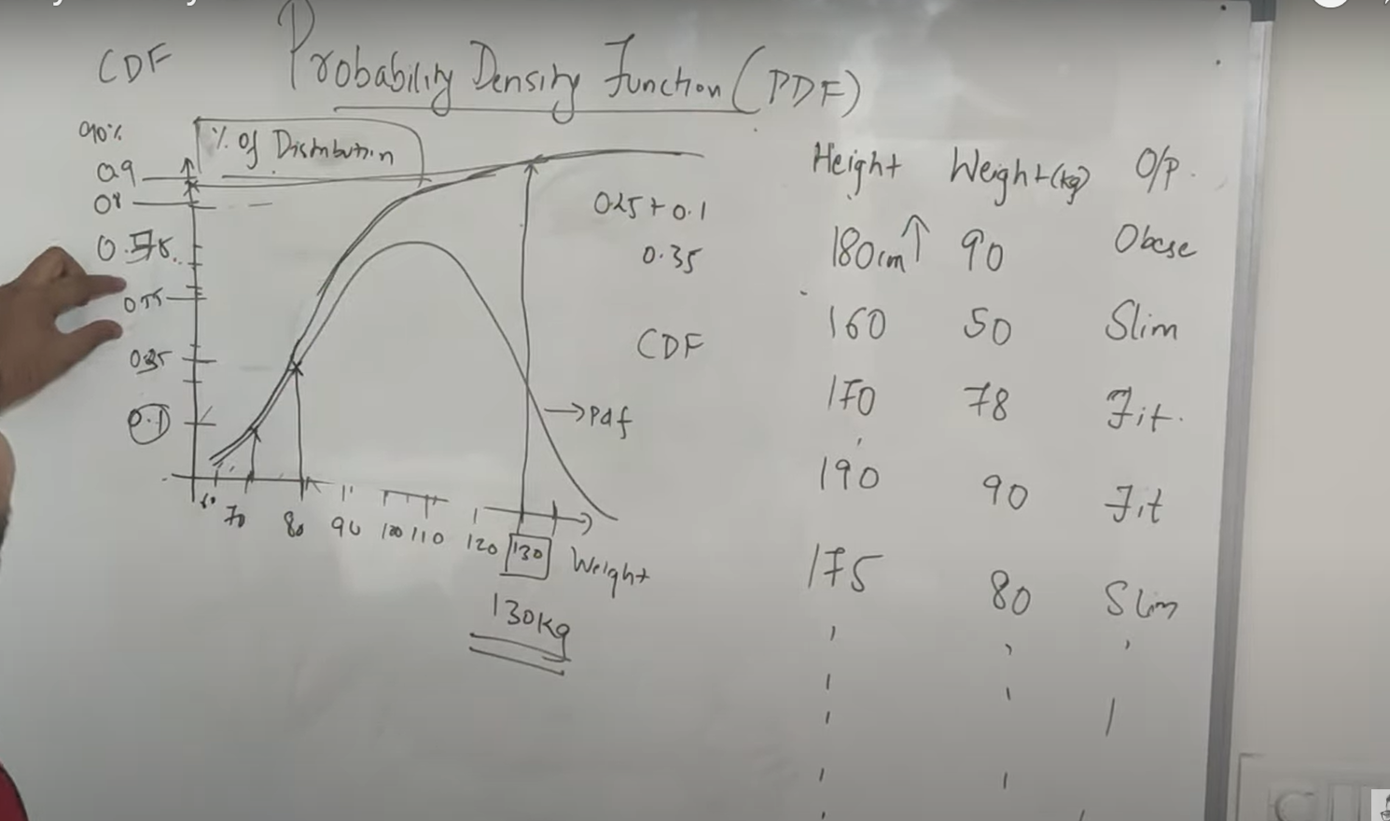

# Mean of Random variable:

